**Configure HTTP Request Defaults**

‘HTTP Request Defaults’ is a very basic and key element of JMeter. This config element is used when all requests in the JMeter script are sent to the same server. You can add a single HTTP Request Defaults element under Test Plan with the proper server name or IP address in the field ‘Server Name or IP’. Now, when you add HTTP Request controllers, then leave the ‘Server Name or IP’ field empty. The controllers will inherit this field value from the HTTP Request Defaults element. Make sure you have provided correct method type in each HTTP Request.

It makes JMeter script simple and easily maintainable. If server name or IP changes, then you do not need to change those details in each HTTP Request. Just make changes in HTTP Request Defaults and that will be applicable for all the HTTP Requests.

It reduces the chances of missing the URL/port changes from HTTP Requests

Steps:

* Create a Test Plan
* Add a Thread Group
* Add HTTP Request Defaults

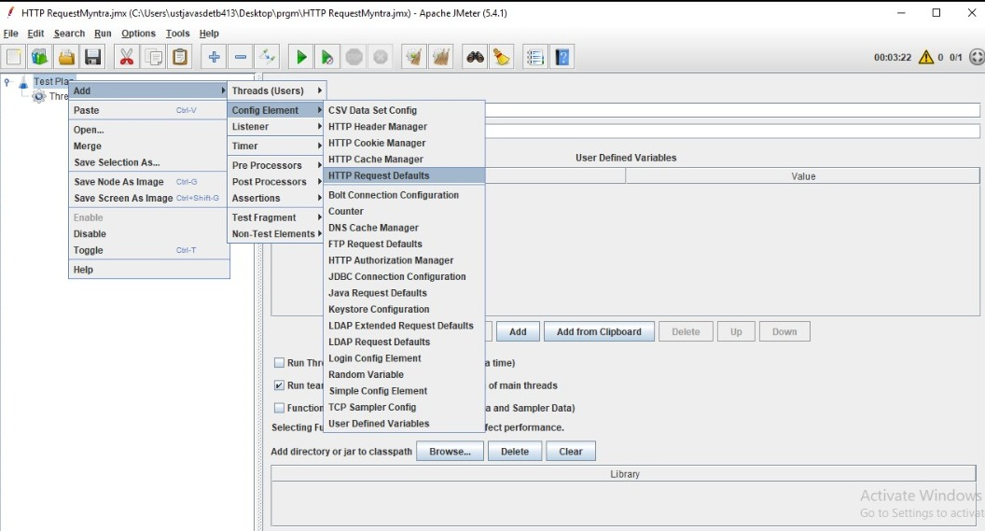

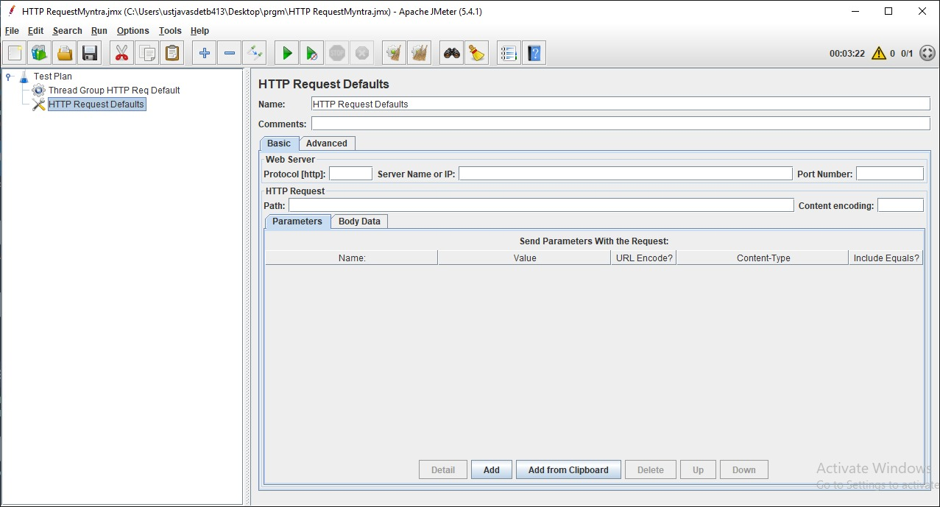

* Name: To provide element name
* Comments: To provide arbitrary comments (if any)
* Protocol [http:]: Either http or https (Do not use ://)
* Server Name or IP: Domain name or IP address of the webserver without including prefix http://
* Port Number: Port number of Web-server. In case there is no port number then keep it blank.
* Path: It is a path to the resource. You can keep it blank for home page request or use /.

Site used for testing is ,



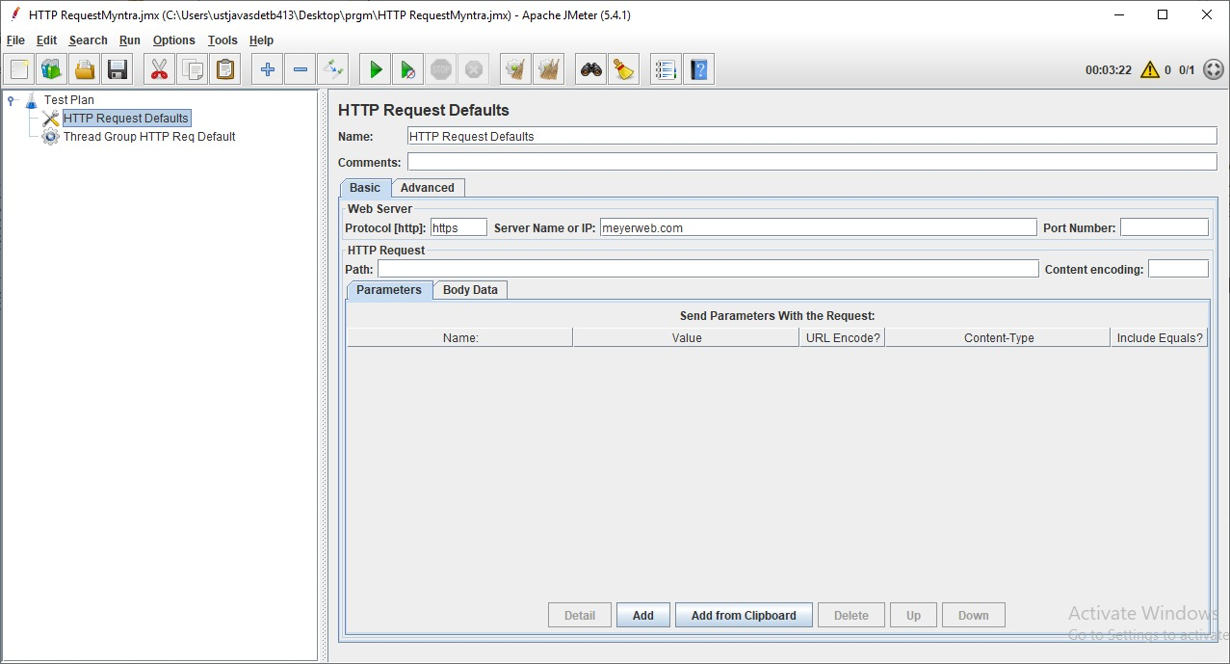

* Add some HTTP Request to the Thread Group

Doesn’t add the Server name/IP only need path

HTTP Request1



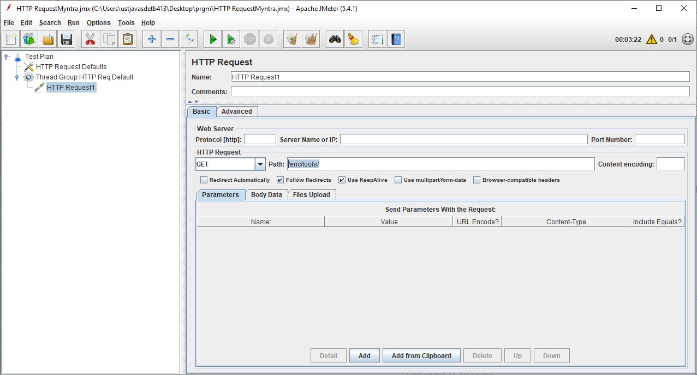

HTTP Request2



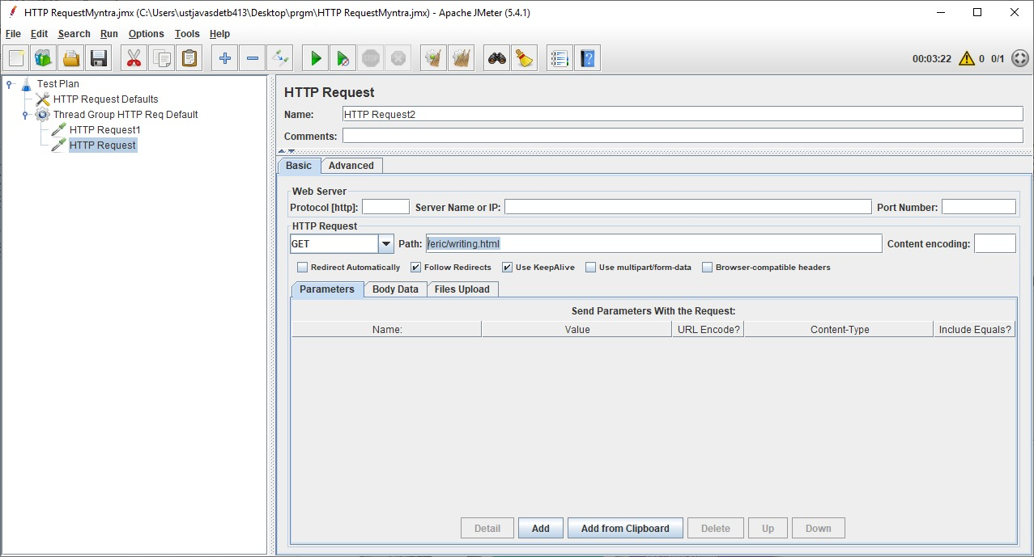

HTTP Request3

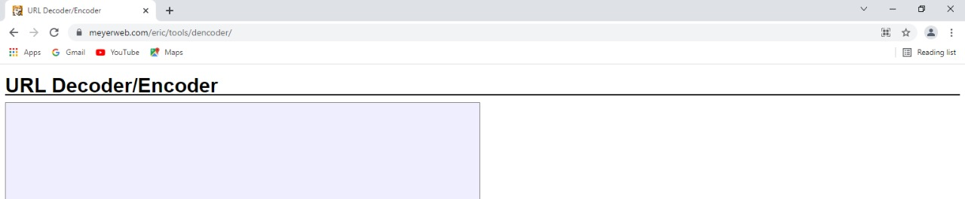

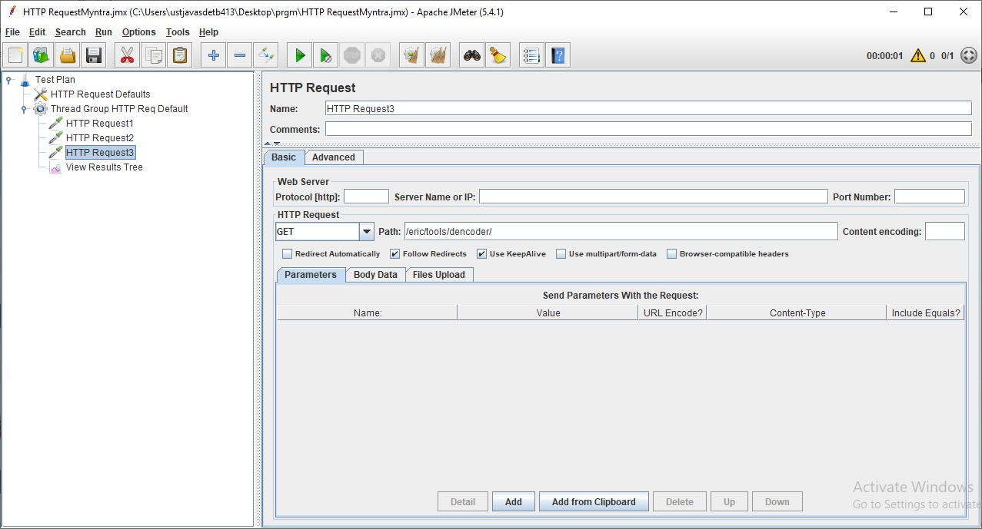

* Add a Listener -View Results Tree
* Run the Test plan

